4. Actuator and Drive System

The robots propulsion system consist of two DC motors powering the rear wheels independently. Steering will be done through differential power distribution to the rear wheels. The front wheels will move freely and in any direction.

Pet retrieval will be done through a large articulated arm. In order to retrieve pets in many different situations the arm will need at least three degrees of freedom.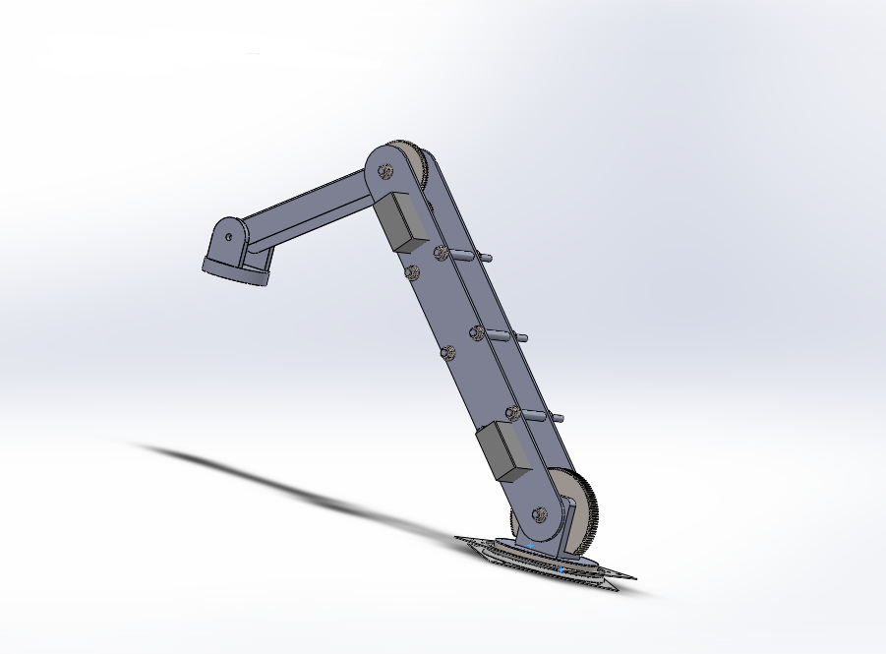

Figure 4‑ ‑1 Pet Retrieval Mechanism

To achieve this the robot will sit on a rotating turntable. The turntable will be made with a “Lazy Susan” bearing attached to the chassis with an internal spur gear driven by a stepper motor. The stepper motor will allow the arm to rotate a greater range than an RC servo would allow, and will simplify the design compared to a DC motor and potentiometer combination. First section of the arm will rotate around a large spur gear fixed to the mounting bracket. The rotation will be driven by an RC servo geared down to approximately a 4:1 ratio.

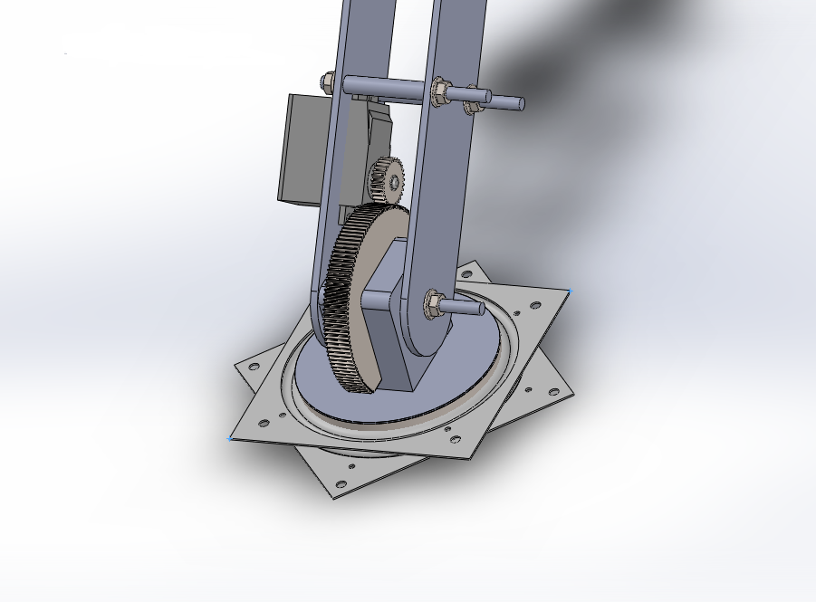

Figure 4‑ 2 Bottom Joint of Robotic Arm

The second segment of the arm will be attached to a large fixed gear and driven by another RC servo mounted on the first arm segment. 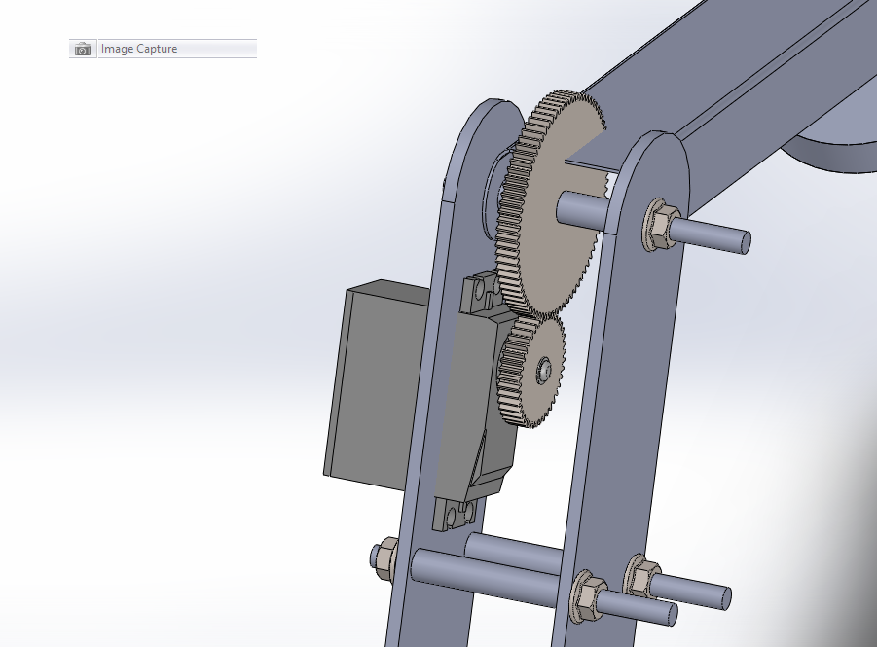

Figure 4 ‑3 Top Joint of Robotic Arm

The final segment of the arm will hang freely and contain the mechanism needed to pick up the pets. This will be done either with an electromagnet or a ferrous plate and release mechanism. Major design considerations for this arm are the length of the arm segments and the gear ratio needed in order to move the arm.

Another key actuator system for the robot is the basket lift mechanism. The purpose of the lift mechanism is to lift the pet basket into position to engage the zipline. In order to do this the robot will use an accordion linkage. The linkage will be driven by an electric motor in a rack and pinion configuration. The basic outline can be observed in the following figures.

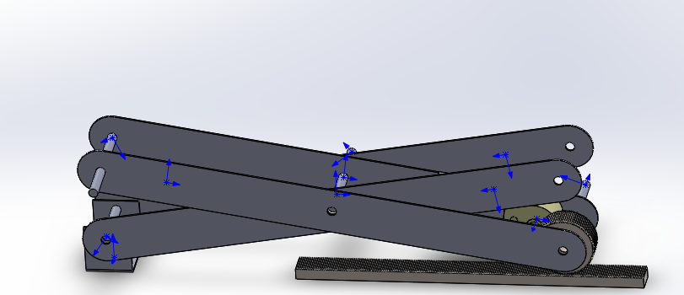

Figure 4‑4 Linkage in collapsed state

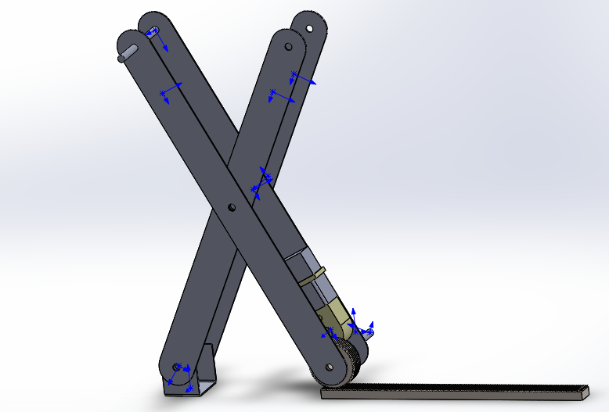

Figure 4‑5 linkage in Extended State

The top of the linkage will support the bottom of the pet basket so that it won’t slide off sideways but when it engages the zipline it can slide off vertically. A very important design consideration for this system is whether the DC motor will have enough torque to extend the linkage from its collapsed position. Because of the geometry of the problem, the torque required will be maximized in this collapsed state. In order to combat this, springs could be placed horizontally at either the top or the bottom of the linkage. These springs would provide enough force to allow the motor to drive the linkage at its weakest point, but not enough to cause the linkage to prematurely extend.